**Day 3 - Date and Time function**

Q.1) Write a query to display the first day of the month (in datetime format) three months before the current month.  
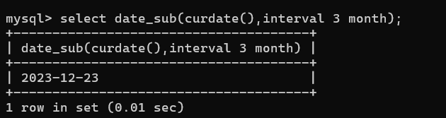

Q.2) Write a query to display the last day of the month (in datetime format) three

months before the current month.

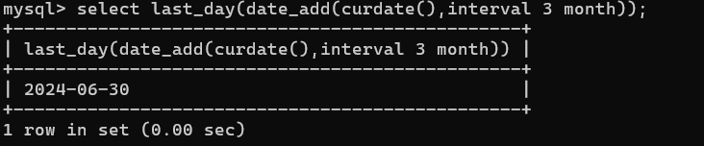

Q.3) Write a query to get the distinct Mondays from hiredate in emp tables.

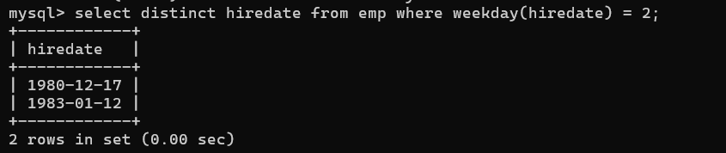

Q.4) Write a query to get the first day of the current year.

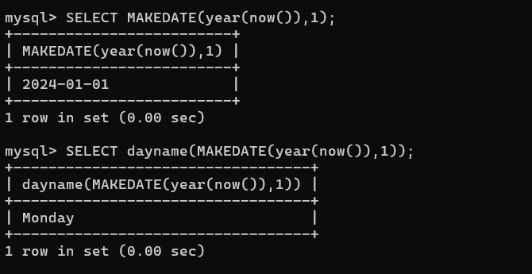

Q.5) Write a query to get the last day of the current year.

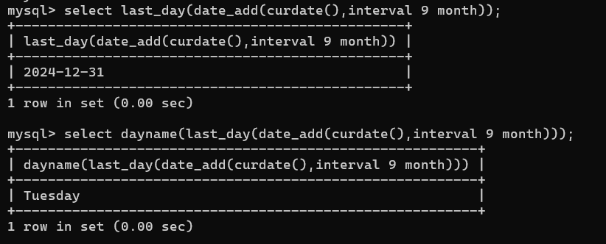

Q.6) Write a query to calculate your age in year.

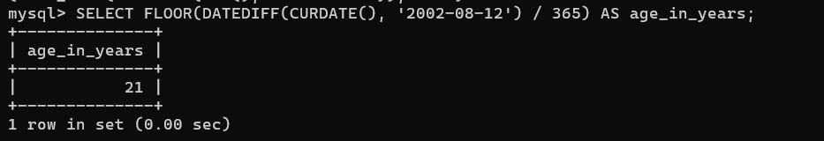

Q.7) Write a query to get the current date in the following format.

Sample date : 04-sep-2014

Output : September 4, 2014

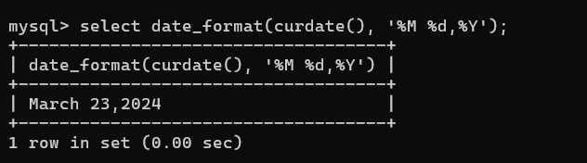

Q.8) Write a query to get the current date in Thursday September 2014 format.

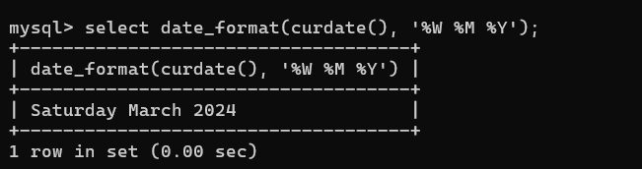

Q.9) Write a query to extract the year from the current date.

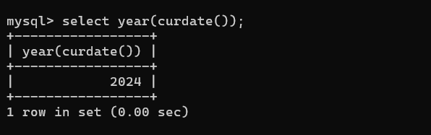

Q.10) Write a query to get the first name and hire date from employees table where hire date between

'1987-06-01' and '1987-07-30'

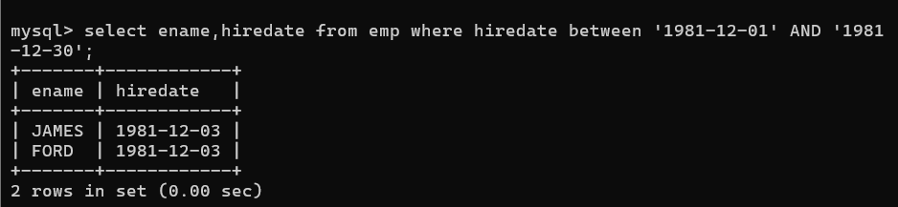

Q.11) Write a query to display the current date in the following format.

Sample output: Thursday 4th September 2014 00:00:00

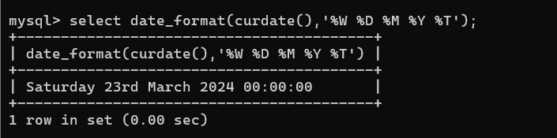

Q.12) Write a query to display the current date in the following format.

Sample output: 05/09/2014

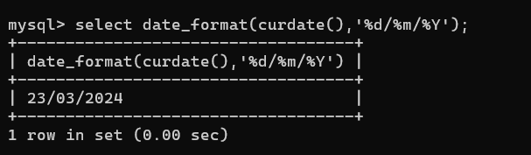

Q.13) Write a query to display the current date in the following format.

Sample output: 12:00 AM Sep 5, 2014

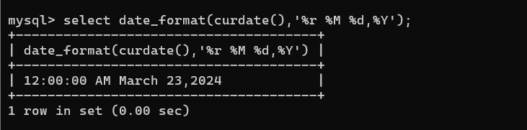

Q.14) Write a query to get the employees who joined in the month of June.

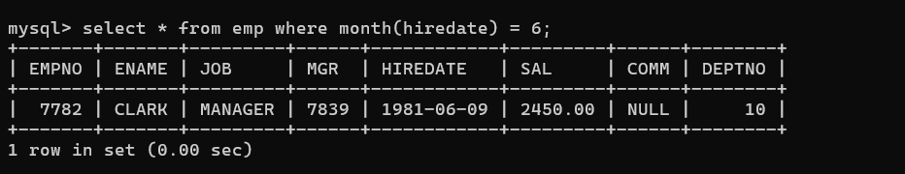

Q.15) Write a query to get the years in which more than 10 employees joined.

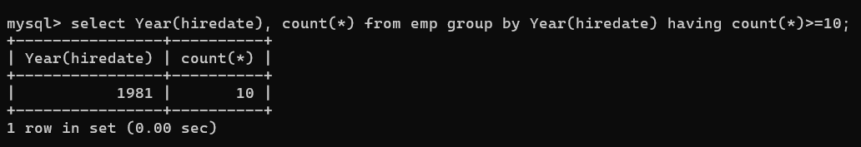

Q.16) Write a query to get first name of employees who joined in 1987.

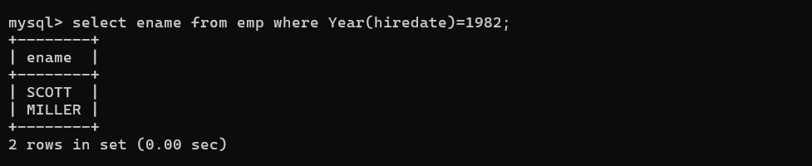

Q.17) Write a query to get employees whose experience is more than 5 years.

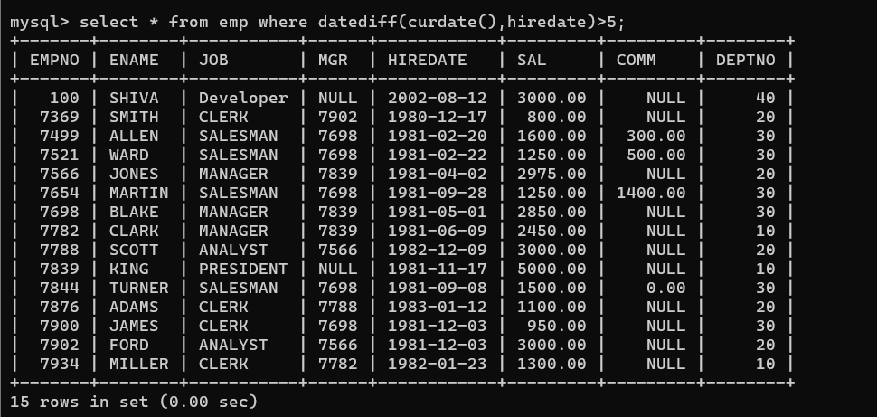

Q.18) Write a query to get employee ID, last name, and date of first salary of the employees.

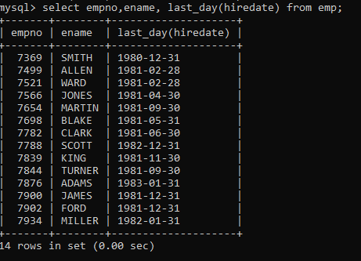

Q.19) Write a query to get first name, hire date and experience of the employees.

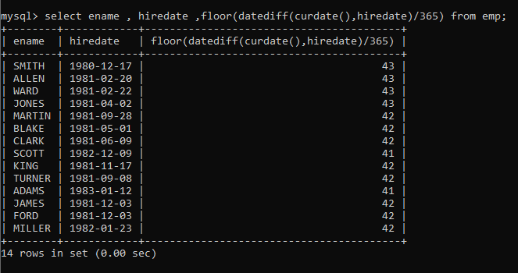

Q.20) Write a query to get the department ID, year, and number of employees joined.

